**DEBREMARKOS UNIVERSITY INSTITUTE OF TECHNOLOGY**

****

**SOFTWARE ENGEINERING ACADAMIC PROGRAM**

**SEMINAR REPORT ON**

**EDGE COMPUTING**

**SUBMITED BY**

**1. Getachw Chanie -------- TEE-0099/10**

**2. Abere Baye ………………………..TEE-0080/10**

**FEBRUARY 2014 E.C**

Table of Contents

[1. INTRODUCTION 1](#_Toc95002635)

[1.1 WHAT IS EDGE COMPUTING 2](#_Toc95002636)

[1.2 WHY DO WE NEED EDGE COMPUTING? 2](#_Toc95002637)

[2. EDGE COMPUTING ARCHITECTURE AND SECURITY 2](#_Toc95002638)

[2.1 How Does Edge Computing Work? 5](#_Toc95002639)

[3. Edge computing implementation 6](#_Toc95002640)

[4. Edge computing applications and some edge examples 8](#_Toc95002641)

[4.1 edge computing applications. 8](#_Toc95002642)

[4.2. Some edge computing examples 9](#_Toc95002643)

[5. Advantages of Edge Computing 10](#_Toc95002644)

[5.1. Speed 10](#_Toc95002645)

[5.3. Reliability 10](#_Toc95002646)

[6. Disadvantages of Edge Computing 11](#_Toc95002647)

[6.1. Security 11](#_Toc95002648)

[6.2. Incomplete Data 11](#_Toc95002649)

[6.3. More Storage Space 11](#_Toc95002650)

[6.4. Investment Cost 11](#_Toc95002651)

[6.5. Maintenance 12](#_Toc95002652)

**[7.](#_Toc95002653)****[Challenges of edge computing](#_Toc95002653)** [12](#_Toc95002653)

[8. The future of edge computing 12](#_Toc95002654)

[9. Conclusion 13](#_Toc95002655)

[9. Reference 13](#_Toc95002656)

**List of figure**

[Figure 1 Typical edge computing architecture 3](#_Toc94999224)

[Figure 2 Edge computing paradigm 4](#_Toc94999225)

[Figure 3 Major tasks of edge computing 5](#_Toc94999226)

# INTRODUCTION

Edge computing originated as a concept in content delivery networks (CDNs) created in the 1990s to deliver video and web content using edge servers deployed closer to the users. In the 2000s, those networks evolved and started hosting apps and app components directly at the edge servers.

This is how the first usage of edge computing appeared commercially. Eventually, edge computing solutions and services were developed to host apps such as shopping carts, data aggregation in real-time, ad insertion, and more

Internet of Things (IoT) was first introduced to the community in 1999 for supply chain management, and then the concept of “making computer sense information without the aid of human intervention” was widely adapted to other fields such as healthcare, home, environment, and transports. Now with IoT, we will arrive in the post-cloud era, where there will be a large quality of data generator by things that are immersed in our daily life, and a lot of applications will also be deployed at the edge to consume these data. By 2019, data produced by people, machines, and things will reach 500 zettabytes, as estimated by Cisco Global Cloud Index, however, the global data centre IP traffic will only reach 10.4 zettabytes by that time. By 2019, 45% of IoT-created data will be stored, processed, analysed, and acted be 50 billion things connected to the Internet by 2020, as predicted by Cisco Internet Business Solutions Group. Some IoT applications might require very short response time, some might involve private data, and some might produce a large quantity of data which could be a heavy load for networks. Cloud computing is not efficient enough to support these applications. With the push from cloud services and pull from IoT, we envision that the edge of the network is changing from data consumer to data producer as well as data consumer. The proliferation of Internet of Things (IoT) and the success of rich cloud services have pushed the horizon of a new computing paradigm, edge computing, which calls for processing the data at the edge of the network. Edge computing has the potential to address the concerns of response time requirement, battery life constraint, bandwidth cost saving, as well as data safety and privacy.

Today the world of technology changes very often. To cope up with this revolution, an organization too has to migrate services. The best example for this is the Edge computing.

### 1.1 WHAT IS EDGE COMPUTING

**Edge computing** is the computational processing of sensor data away from the centralized nodes and close to the logical edge of the network, toward individual sources of data. It creates a new kind of approach to the network architecture.It is the deployment of computing and storage resources at the location where data is produced.

Edge computing is a distributed information technology (IT) architecture in which client data is processed at the periphery of the network, as close to the originating source as possible.Instead of sending the data to cloud data centers, edge computing decentralizes processing power to ensure real-time processing without latency while reducing bandwidth and storage requirements on the network.

Data is increasingly produced at the edge of the network; therefore, it would be more efficient to also process the data at the edge of the network. Previous work such as micro data centres cloudlet, and fog computing has been introduced to the community because cloud computing is not always efficient for data processing when the data is produced at the edge of the network.

### 1.2 WHY DO WE NEED EDGE COMPUTING?

Edge computing enables data-stream acceleration, including real-time data processing without latency.

It allows smart applications and devices to respond to data almost instantaneously, as its being created, eliminating lag time. This is critical for technologies such as self-driving cars, and has equally important benefits for business.

# EDGE COMPUTING ARCHITECTURE AND SECURITY

Edge Computing is a distributed architecture, simply defined as the processing of data when it is collected. It has been emerged to minimize both bandwidth and time response in an IoT system. The use of an edge computing technique is required when the latency is required to be optimized to avoid network saturation as well as when the data processing burden is high at a centralized infrastructure. An extended version of edge computing is fog computing, which is an architecture that makes use of edge gadgets to accomplish a considerable amount of computation, storage, communication regionally, which undoubtedly possesses input and output from the real world referred to as transduction. Fog nodes determine whether to process the data locally from several data sources or send the data out to cloud.

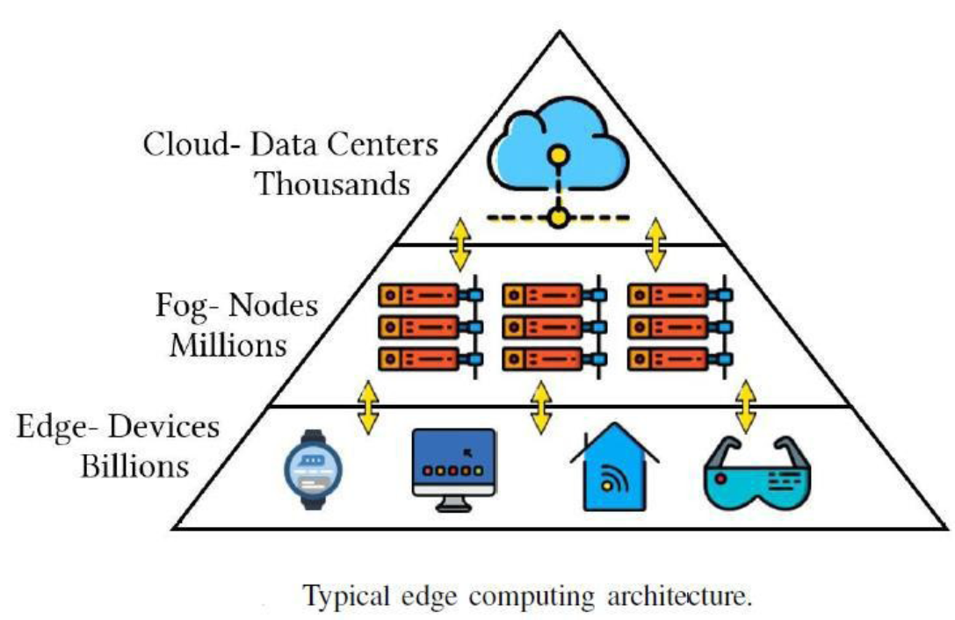

Figure 1 Typical edge computing architecture

Edge computing is expected act as a strategic brain behind IoT. Identifying the role of edge computing in IoT is the main research issue at present. Edge computing is utilized to reduce the amount of data sent to the cloud and decrease service access latency. Figure illustrates the complimentary role of edge and cloud computing in the IoT environment

****

Figure 2 Edge computing paradigm

The tasks of edge computing, which people carry out in a daily manner.

There are three basic elements: input, processing, and output as summarized based.

• Data sources: As the input, any endpoint which records and collects data from clients or its environments is described as a data source.

• Artificial intelligence: As the processing function, it is the main facet after data collected to uncover practical observations, locate patterns and trends, produce individualized recommendations, and improve the performance based on machine learning or data analytics models.



Figure 3 Major tasks of edge computing

### 2.1 How Does Edge Computing Work?

The edge computing concept is not entirely new; it dates back to decades associated with remote computing. For example, branch offices and remote workplaces placed computing resources at a location where they can reap maximum benefits instead of relying on a central location.

In traditional computing, where data was produced at the client-side (like a user’s PC), it moved across the internet to corporate LAN to store data and process it using an enterprise app. Next, the output is sent back, traveling through the internet, to reach the client’s device.

Now, modern IT architects have moved from the concept of centralized data centers and embraced the edge infrastructure. Here, the computing and storage resources are moved from a data center to the location where the user generates the data (or the data source).

This implies that you are bringing the data center close to the data source, not the other way around. It requires a partial gear rack that helps operate on a remote LAN and collects the data locally to process it. Some may deploy the gear in shielded enclosures to safeguard it from high temperature, humidity, moisture, and other climatic conditions.

The edge computing process involves data normalization and analysis to find business intelligence, sending only the relevant data after analysis to the main data center. Furthermore, business intelligence here can mean:

* Video surveillance in retail shops
* Sales data
* Predictive analytics for equipment repair and maintenance
* Power generation,
* Maintaining product quality,
* Ensure proper device functioning and more

# Edge computing implementation

Edge computing is a straightforward idea that might look easy on paper, but developing a cohesive strategy and [implementing a sound deployment at the edge](https://internetofthingsagenda.techtarget.com/tip/How-to-implement-edge-computing-in-5-steps) can be a challenging exercise.

The first vital element of any successful technology deployment is the creation of a meaningful business and [technical edge strategy](https://searchdatacenter.techtarget.com/tip/Top-guidelines-for-edge-computing-software-selection). Such a strategy isn't about picking vendors or gear. Instead, an edge strategy considers the need for edge computing. Understanding the "why" demands a clear understanding of the technical and business problems that the organization is trying to solve, such as overcoming network constraints and observing data sovereignty. An edge data center requires careful upfront planning and migration strategies.

Such strategies might start with a discussion of just what the edge means, where it exists for the business and how it should benefit the organization. Edge strategies should also align with existing business plans and technology roadmaps. As the project moves closer to implementation, it's important to evaluate hardware and software options carefully. There are many [vendors in the edge computing space](https://www.techtarget.com/searchcio/tip/5-edge-computing-vendors-for-CIOs-to-watch), including Adlink Technology, Cisco, Amazon, Dell EMC and HPE. Each product offering must be evaluated for cost, performance, features, interoperability and support. From a software perspective, tools should provide comprehensive visibility and control over the remote edge environment.

An edge deployment demands comprehensive monitoring. Remember that it might be difficult -- or even impossible -- to get IT staff to the physical edge site, so edge deployments should be architected to provide resilience, fault-tolerance and self-healing capabilities. Monitoring tools must offer a clear overview of the remote deployment, enable easy provisioning and configuration, offer comprehensive alerting and reporting and maintain security of the installation and its data.

And no edge implementation would be complete without a careful consideration of edge maintenance:

* **Security.** Physical and logical security precautions are vital and should involve tools that emphasize vulnerability management and intrusion detection and prevention.
* **Connectivity.** Connectivity is another issue, and provisions must be made for access to control and reporting even when connectivity for the actual data is unavailable
* **Management.** The remote and often inhospitable locations of edge deployments make remote provisioning and management essential.
* **Physical maintenance.** Physical maintenance requirements can't be overlooked. IoT devices often have limited lifespans with routine battery and device replacements. Gear fails and eventually requires maintenance and replacement. Practical site logistics must be included with maintenance

**Six steps to implement effective edge computing**

1. Strive to identify pain points and  operations that could benefit from edge computing, even though potential opportunities may not be apparent in existing applications and networks;
2. Recruit OT and IT staffs, who can show where edge computing might  solve problems and improve production, and invite all stakeholders to develop a plan for migrating to edge devices and software;
3. Draft edge program specifications based on requirements, such as application cycles, lags and turnaround periods, and required response times to determine how close to real-time an edge-computing solution will need to be, or if a cloud service would be sufficient;
4. Determine what data should be handled by local/edge devices, where to retain  it, and what should be reported to the cloud and administrative/business platforms, and on what schedule to deliver it;
5. Research and decide which edge components and enabling devices will satisfy the edge project's requirements, such as where to locate computing functions, how to tie in legacy equipment, what Ethernet infrastructure and communication protocols to use, whether to employ wired or wireless, and linking to PLCs and servers; and
6. Evaluate and enable the most appropriate [cybersecurity](https://www.controlglobal.com/category/cybersecurity" \t "_blank" \o "Read more about cybersecurity) capabilities are each stage of the edge computing application and its network.

# Edge computing applications and some edge examples

## 4.1 edge computing applications.

* **Manufacturing**: Adaptive diagnostics in an industrial setting can be improve the uptime of machines and equipment, cutting service expenses
* **Smart Cities**: Edge compute enables public buildings and facilities to be monitored for greater efficiency in lighting, heating and more. In traffic management applications, cameras and signals can improve safety and traffic flow. In the near future, autonomous vehicles, where near-zero latency is critical,
* **Healthcare**: Wearable devices can store information on heart rate, temperature, and other metrics, then provide reminders for medication. In addition, edge computing enables developers to ensure sensitive data, such as medical imagery, does leave the device to enhance security and privacy.

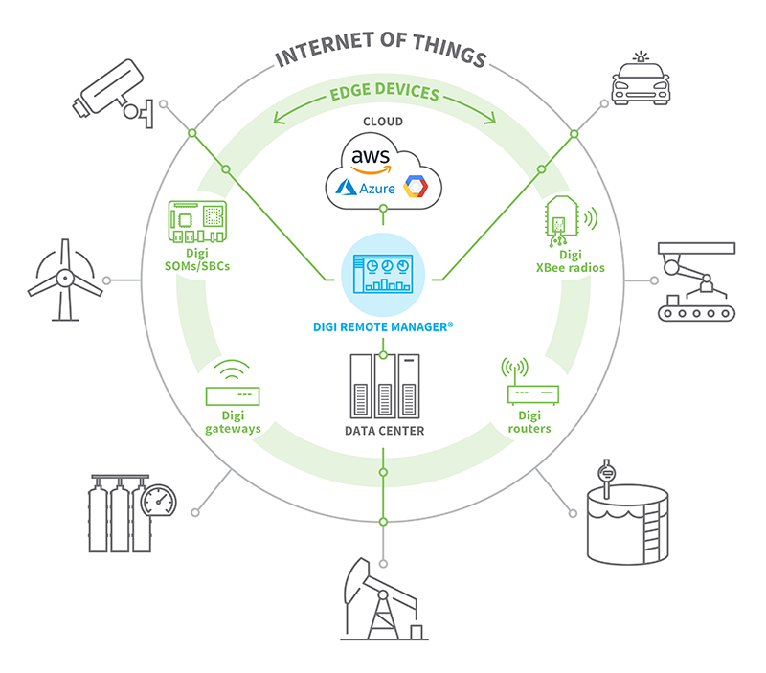

## Some edge computing examples

**Voice Assistants**

Voice assistant **[conversational interfaces](https://theappsolutions.com/blog/development/guide-to-conversational-user-interfaces/)** are probably the most prominent example of edge computing at the consumer level. The most prominent examples of this type are Apple Siri, Google Assistant, Amazon Dot Echo, and the likes. These applications combine voice recognition and process automation algorithms.

**Self-driving cars**

At the moment, Tesla is one of the leading players in the autonomous vehicle market. The other automotive industry giants like Chrystler and BMW are also trying their hand at self-driving cars. In addition to this, Uber and Lyft are testing autonomous driving systems as a service.

**Healthcare**

Healthcare is one of those industries that take the most out of emerging technologies. Edge computing is no different.

Internet-of-things devices are extremely helpful when it comes to such [healthcare data science](https://theappsolutions.com/blog/development/data-science-healthcare/) tasks as patient monitoring and general health management. In addition to organizer features, it is able to check the heart and caloric rates.

* Wearable IoT devices such as smartwatches are capable of monitoring the user’s state of health and even save lives on occasions if necessary.

**Retail & Ecommerce**

Retail and ecommerce applies various edge computing applications (like [geolocation beacons](https://theappsolutions.com/blog/reviews/geolocation-beacons-explained/)) to improve and refine customer experience and gather more ground-level business intelligence. Edge computing enables streamlined data gathering.

**Current Providers of Edge Computing**

To deploy edge computing quickly and easily in your business or enterprise, you require an edge computing service provider. They help process the data and transmit it efficiently, offer a robust IT infrastructure, and manage massive data generated from the edge devices.

**Here are some of the notable edge computing providers:**

**1. Amazon Web Services**

AWS offers consistent experience with a cloud-edge model and provides solutions and services for IoT, ML, AI, analytics, robotics, storage, and computation.

**2. Dell**

Dell provides edge computing orchestration and management through OpenManage Mobile. Dell is great for digital cities, retailers, manufacturers, and others.

**3. ClearBlade**

ClearBlade released their Edge Native Intelligent Asset Application that allows an edge maintainer to build alert devices and connect to IoT devices without coding. Other notable edge computing providers are Cloudflare, StackPath, Intel, EdgeConnex, and more.

# 5. Advantages of Edge Computing

5.1. Speed  
Every millisecond in a company is vital for their business. As of result of downtime or latency can cost them with thousands of dollars. Edge computing has the capability to increase network speed by reducing latency. It greatly reduces the distance it should travel by processing data closer to the source of information.   
5.2. Security  
The informations present on the cloud has the tendency to get hacked easily. Since the edge computing only sends the relevant informations to the cloud this can be prevented. Sometimes the edge computing does not require a network connection at all.

5.3. Reliability  
  
Edge computing handles reliability part very well. Since most at times the edge computing does not depend on internet connection and servers it offers an uninterruptible service. Users do not need to worry about network failures or slow internet connections.   
5.4. Cost  
  
Adopting an IoT service can be costly due to their need of more network bandwidth, data storage and computational power. Using edge computing for IoT allows users to reduce the bandwidth and data storage requirement and replace datacenters with device solutions.  
  
5.5. Scalability  
In cloud computing architecture, the data needs to be forwarded to a centralized datacenter. Most at times modifying or expanding this datacenter can be costly. However the edge can be used to scale your own IoT network without needing to worry about the storage requirements.

# 6. Disadvantages of Edge Computing

6.1. Security  
ensuring adequate security can be often challenging in an edge distributed environment. Due to the fact that data processing takes place at the outside edge of the network there are often risks of identity theft and cyber security breaches

6.2. Incomplete Data  
Edge computing only process and analyze partial sets of information. The rest of the data’s are just discarded. Due to this the companies may end up losing lots of valuable information’s.

6.3. More Storage Space  
Edge computing does take a considerably higher storage space on your device. Since the storage devices are becoming more compact this will not actually be a problem.

6.4. Investment Cost  
implementing an edge infrastructure can be costly and complex. This is due to their complexity which needs additional equipment and resources. In addition to that the IoT device with the edge computing comes with the need of more local hardware for them to function.

6.5. Maintenance  
Unlike a centralized cloud architecture, edge computing is a distributed system. Which means that there are more various network combinations with several computing nodes. This requires higher maintenance cost than a centralized infrastructure.

1. **Challenges of edge computing**

Beyond the traditional problems of network limitations, there are several key considerations that can affect the adoption of edge computing:

* **Limited capability.** Part of the allure that cloud computing brings to edge -- or fog -- computing is the variety and scale of the resources and services. Deploying an infrastructure at the edge can be effective, but the scope and purpose of the edge deployment must be clearly defined -- even an extensive edge computing deployment serves a specific purpose at a pre-determined scale using limited resources and few services
* **Connectivity.**Edge computing overcomes typical network limitations, but even the most forgiving edge deployment will require some minimum level of connectivity. It's critical to design an edge deployment that accommodates poor or erratic connectivity and consider what happens at the edge when connectivity is lost..
* **Security.** IoT devices are notoriously insecure, so it's vital to design an edge computing deployment that will emphasize proper device management, such as policy-driven configuration enforcement, as well as security in the computing and storage resources -- including factors such as software patching and updates –

# 8. The future of edge computing

According to the Gartner Hype Cycle, edge computing is drawing closer to the [Peak of Inflated Expectations](https://www.bmc.com/blogs/hype-cycle-peak-of-inflated-expectations/" \t "_self) and will likely reach the [Plateau of Productivity](https://www.bmc.com/blogs/hype-cycle-plateau-of-productivity" \t "_self) in 2-5 years. Considering the ongoing research and developments in AI and 5G connectivity technologies, and the rising demands of smart industrial IoT applications, Edge Computing may reach maturity faster than expected.

# Conclusion

Edge computing has its pros and cons, but most IT experts agree that it isn't going away anytime soon, especially with the expected expansion of 5G access. Edge computing and how it's used are changing rapidly as more number of users are accessing data using various types of gadgets.

Nowadays, more and more services are pushed from the cloud to the edge of the network because processing data at the edge can ensure shorter response time and better reliability. Moreover, bandwidth could also be saved if a larger portion of data could be handled at the edge rather than uploaded to the cloud. The burgeoning of IoT and the universalized mobile devices changed the role of edge in the computing paradigm from data consumer to data producer/consumer. It would be more efficient to process or massage data at the edge of the network. In this paper, we came up with our understanding of edge computing; with the rationale that computing should happen at the proximity of data sources.

We conclude that although the deployment of edge computing in IoT provides numerous benefits, the convergence of these two computing paradigms brings about new issues that should be resolved in the future

Edge computing can be an efficient, reliable, and cost-saving option for modern businesses that use digital services and solutions than ever before. It’s also an excellent concept to support the [remote work culture](https://geekflare.com/remote-workers-productivity/) to facilitate faster data processing and communication.

# 9. Reference

[1} Ecure Edge Computing in IoT Systems: Review and Case Studies, Mohammed Alrowaily Department of Electrical Engineering University of South Florida, Zhuo Lu Department of Electrical IEEE,2018

[2] The Role of Edge Computing in Internet of Things , Najmul Hassan, Saira Gillani, Ejaz Ahmed IEEE, Ibrar Yaqoob, and Muhammad Imran, IEEE,2018